**M.H. Saboo Siddik College of Engineering**

**Department of Computer Engineering**



**A Project Report on**

**“HOSPITAL MANAGEMENT SYSTEM”**

Submitted in Partial Fulfilment of Requirements

of the Course

**Bachelor of Engineering**

**(Semester IV)**

**BY**

**USAID HUSSAIN(3117064)**

**SOMIL VIRANI(3117065)**

Under the Guidance of

**Prof. Saiqa Khan**

**2019-20**

ACKNOWLEDGEMENT

We would like to express our special thanks of gratitude to our Teacher Prof. Saiqa Khan as well as to Zainab Pirani HOD, Department of Computer Engineering, who gave us the golden opportunity to do this wonderful project in the course Database Management System, which also helped us in doing a lot of research and we came to know about so many new things we are really thankful to them.

We would like to thank all our faculty and friends for their help and constructive criticism during the project period. Finally, we are very much indebted to our parents for their moral support and encouragement to achieve goals.

Usaid Hussain (3117064)

Somil Virani (3117065)

PROBLEM DEFINITION

XYZ hospital is a multi specialty hospital that includes a number of departments, rooms, doctors, nurses, compounders, and other staff working in the hospital. Patients having different kinds of ailments come to the hospital and get checkup done from the concerned doctors. If required they are admitted in the hospital and discharged after treatment.

In hospital, resides many departments like Orthopedic, Pathology, Emergency, Dental, Gynecology, Anesthetics, I.C.U., Blood Bank, Operation Theater, Laboratory, M.R.I., Neurology, Cardiology, Cancer Department, Corpse, etc. There is an OPD where patients come and get a card (that is, entry card of the patient) for check up from the concerned doctor. After making entry in the card, they go to the concerned doctor’s room and the doctor checks up their ailments.

According to the ailments, the doctor either prescribes medicine or admits the

patient in the concerned department. The patient may choose either private or general room according to his/her need. But before getting admission in the hospital, the patient has to fulfill certain formalities of the hospital like room charges, etc. After the treatment is completed, the doctor discharges the patient. Before discharging from the hospital, the patient again has to complete certain formalities of the hospital like balance charges, test charges, operation charges (if any), blood charges, doctors’ charges, etc.

DESIGN

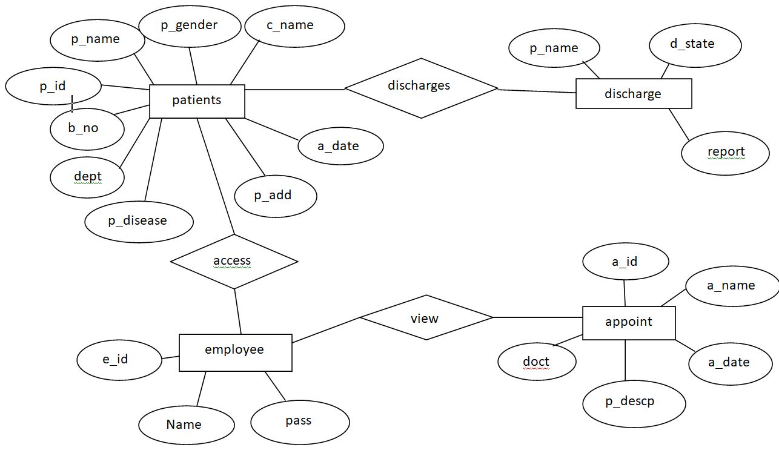

Fig. ER Diagram of Hospital Management System

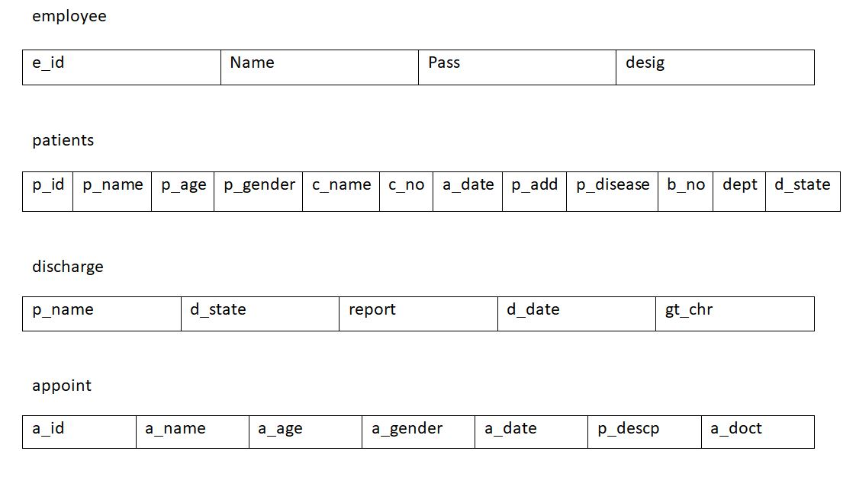

Fig. Relational Model of Hospital Management System

AIM

The aim of project is to design and develop a Java Application using applet and Swing with a database for the hospital to maintain the records of various departments and doctors in the hospital. It also maintains records of the regular patients, patients admitted in the hospital, the check up of patients done by the doctors, the patients that have been operated, and patients discharged from the hospital.

It includes receptionist login which give them access to current admitted patient’s details. If a new patient is to be admitted then the receptionist can fill in details for new patient and generate new id for patient.

Discharge form allows receptionist to fill discharge details if and only if the name matches with one of the current patient. Discharge form includes name, state (cured, absconded, and dead), and full discharge report. The appointments from the patients can be only read by receptionist

Similarly doctors can only view their appointments and also see or change details. Admin login enables to add or delete employees.

Every page with a form will have client-side as well as server-side validation.

OBJECTIVES

* To create a Java Application using Applet and Swing for Hospital Management System with a JDBC for storing the data.
* To give receptionist access to all details of patients as well as add and discharge patients as per hospital
* To provide appointment details to doctors for ease of documentations and chaos.
* To give admin the power to add and delete employees.
* To give employees to change their own details such as name, password etc.
* To link the entire system to a reliable and fast database which uses MySQL JDBC
* To make the system user-friendly and improve GUI.
* To validate the forms every time anything is updated or added.
* To automate hospital and provide better service.

CONCLUSION

Hence, we have created a Java Application using Applet and Swing for Hospital Management System with a JDBC for storing the data. The application works flawlessly and the operations are smoothly executed. MySQL JDBC was used for this project which is very simple to use and efficient Database System. The GUI was also very well-designed and user- friendly. Minute details have been kept in mind, making the system a catch in eye gem.

Receptionists can view details of the patients as well as add and discharge patients. They can also update details if any wrong input is provided.

Doctor privileges only include viewing appointments associates with them.

The admin can add or delete employee with proper password and auto generated patient id.

Client and server-side validations are present wherever required to guide the admin as well as the employees to enter correct information for maintaining consistency and completeness in the database.

FUTURE SCOPE

The application is limited to only displaying and updating basic details, salary and leaves but it can be upgraded quite a lot. Some of the features that can be added to it are as follows:

1. Whole system can be connected via remote servers hence enbling multiple branches to manage data
2. This system can be clubbed with payroll system for employees to view monthly salary slip
3. An emailing system can be added to it which will be used to fill patient details on finger tips by kin of patient hence reducing workload on reception
4. It can be integrated with an attendance system which will automatically add leaves of employees.
5. A website added for patients to remotely book appointments with doctors
6. Hospital research center allows users to view advancements in medical stream

REFERENCES

1. Abraham Silberschatz, Henry F. Korth, S. Sudarshan, “Database System Concepts”, Sixth Editon,2016.
2. Alan Beaulieu, “Learning SQL”, 2nd Edition, 2005.
3. Netbeans.org, 'Connecting to a My SQL Database'. [Online].

Available: https://netbeans.org/kb/docs/ide/mysql.html. [Accessed: 1-Sept- 2019].

1. w3Schools.com, 'Sql Auto-Increment Field', . [Online]. Available: https://[www.w3schools.com/sql/sqlautoincrement.asp.](http://www.w3schools.com/sql/sqlautoincrement.asp) [Accessed: 2-Sept- 2019].
2. youtube.com, ‘How to Design Registration Page using Java', . [Online]. Available: https://[www.youtube.com/watch?v=ieVrk9RnHaI.](http://www.youtube.com/watch?v=ieVrk9RnHaI) [Accessed: 1-Sept- 2019].
3. https://blog.eduonix.com, Learn To Create A Login Page Class Form In Java Using Netbeans', . [Online]. Available: https://blog.eduonix.com/java- programming-2/learn-create-login-page-class-form-java-using-netbeans/. [Accessed: 3-Sept-2019].

**CODE:**

**login.java**

package app;

import java.awt.Color;

import java.sql.*;

import javax.swing.JOptionPane;

public class login extends javax.swing.JFrame {

public login() {

initComponents();

getRootPane().setBackground(Color.black);

getContentPane().setBackground(Color.black);

}

private void formWindowActivated(java.awt.event.WindowEvent evt) {

// TODO add your handling code here:

}

private void jTextField1ActionPerformed(java.awt.event.ActionEvent evt) {

// TODO add your handling code here:

}

private void jButton1ActionPerformed(java.awt.event.ActionEvent evt) {

String e_id = jTextField1.getText();

String pass = jPasswordField1.getText();

if(e_id.equals("0000") && pass.equals("admin"))

{new admin().setVisible(true);

this.dispose();

}

try {

Class.forName("com.mysql.jdbc.Driver");

Connection con;

con = DriverManager.getConnection(

"jdbc:mysql://localhost:3306/hospital","root","");

String query = "select Name,desig from employee where e_id='" + e_id + "' and pass='" + pass + "'";

Statement stmt=con.createStatement();

ResultSet rs=stmt.executeQuery(query);

rs.next();

int rowCount = rs.getRow();

if(rowCount == 1)

{ String name= rs.getString(1);

String desig= rs.getString(2);

if(desig.equals("R")){

new recption(name).setVisible(true);

this.dispose();

}

else{

new doctr(name).setVisible(true);

this.dispose();

}

} else{

jLabel1.setText(jLabel1.getText() + "*");

jLabel1.setForeground(Color.RED);

jLabel3.setText(jLabel3.getText() + "*");

jLabel3.setForeground(Color.RED);

jTextField1.setText("");

jPasswordField1.setText("");

jTextField1.requestFocus();

JOptionPane.showMessageDialog(null, "Employee ID or Password do not match");

}

con.close();

} catch(Exception e){

JOptionPane.showMessageDialog(null, e);

}

}

private void jPasswordField1ActionPerformed(java.awt.event.ActionEvent evt) {

}

try {

for (javax.swing.UIManager.LookAndFeelInfo info : javax.swing.UIManager.getInstalledLookAndFeels()) {

if ("Nimbus".equals(info.getName())) {

javax.swing.UIManager.setLookAndFeel(info.getClassName());

break;

}

}

} catch (ClassNotFoundException ex) {

java.util.logging.Logger.getLogger(login.class.getName()).log(java.util.logging.Level.SEVERE, null, ex);

} catch (InstantiationException ex) {

java.util.logging.Logger.getLogger(login.class.getName()).log(java.util.logging.Level.SEVERE, null, ex);

} catch (IllegalAccessException ex) {

java.util.logging.Logger.getLogger(login.class.getName()).log(java.util.logging.Level.SEVERE, null, ex);

} catch (javax.swing.UnsupportedLookAndFeelException ex) {

java.util.logging.Logger.getLogger(login.class.getName()).log(java.util.logging.Level.SEVERE, null, ex);

}

//</editor-fold>

//</editor-fold>

/* Create and display the form */

java.awt.EventQueue.invokeLater(new Runnable() {

@Override

public void run() {

new login().setVisible(true);

}

});

}

}

**recption.java**

package app;

import java.awt.Color;

import java.sql.Connection;

import java.sql.DriverManager;

import java.sql.PreparedStatement;

import java.sql.ResultSet;

import java.sql.SQLException;

import java.sql.Statement;

import java.time.LocalDateTime;

import java.time.format.DateTimeFormatter;

import javax.swing.JOptionPane;

import javax.swing.table.DefaultTableModel;

recption extends javax.swing.JFrame {

String name1=null;

String timed=null;

double g_total=-1;

int pi_id=0;

/**

* Creates new form NewJFrame

*/

public recption() {

initComponents();

update2();

update1();

jLabel27.setVisible(false);

jLabel28.setVisible(false);

jLabel29.setVisible(false);

jButton11.setVisible(false);

jPanel9.setVisible(false);

jLabel32.setVisible(false);

//getRootPane().setBackground(Color.black);

getContentPane().setBackground(Color.black);

}

public recption(String name){

name1=name;

initComponents();

jLabel2.setText(name1);

update2();

update1();

jLabel27.setVisible(false);

jLabel28.setVisible(false);

jLabel29.setVisible(false);

jButton11.setVisible(false);

jPanel9.setVisible(false);

jLabel32.setVisible(false);

//getRootPane().setBackground(Color.black);

getContentPane().setBackground(Color.black);

}

public String time1(){

DateTimeFormatter dtf = DateTimeFormatter.ofPattern("yyyy-MM-dd HH:mm:ss");

LocalDateTime now = LocalDateTime.now();

timed=dtf.format(now);

//System.out.print(dtf.format(now));

return(timed);

}

public static boolean isNumeric(String s) {

if (s == null || s.equals("")) {

return false;

}

for (int i = 0; i < s.length(); i++) {

char c = s.charAt(i);

if (c < '0' || c > '9') {

return false;

}

}

return true;

}

private void jButton1ActionPerformed(java.awt.event.ActionEvent evt) {

if(jTextField1.getText().equals("")){

jLabel6.setForeground(Color.red);

if(jTextField6.getText().equals("")|| isNumeric(jLabel5.getText()) != true){

jLabel7.setForeground(Color.red);

if(jTextField3.getText().equals("")){

jLabel9.setForeground(Color.red);

if(jTextField4.getText().equals("")){

jLabel10.setForeground(Color.red);

if(jTextPane3.getText().equals("")){

jLabel10.setForeground(Color.red);

if(jTextPane4.getText().equals("")){

jLabel12.setForeground(Color.red);

if(jTextField7.getText().equals("")|| isNumeric(jLabel5.getText()) != true){

jLabel13.setForeground(Color.red);}

}}}}}}

try {

int p_id = pi_id;

String p_name = jTextField1.getText();

int p_age = Integer.parseInt(jTextField6.getText());

String p_gender = jComboBox1.getSelectedItem().toString();

if("Male".equals(p_gender)){p_gender="M";}

else{ p_gender="F";}

String c_name = jTextField3.getText();

String c_no = jTextField4.getText();

String a_date= time1();

String p_add = jTextPane3.getText();

String p_disease = jTextPane4.getText();

int b_no = Integer.parseInt(jTextField7.getText());

String dept = jComboBox3.getSelectedItem().toString();

String d_state = "Admitted";

// TODO add your handling code here:

Class.forName("com.mysql.jdbc.Driver");

Connection con;

con = DriverManager.getConnection(

"jdbc:mysql://localhost:3306/hospital","root","");

String query = "INSERT INTO patients VALUES(?,?,?,?,?,?,?,?,?,?,?,?)";

PreparedStatement stmt=con.prepareStatement(query);

stmt.setInt(1, p_id);

stmt.setString(2, p_name);

stmt.setInt(3, p_age);

stmt.setString(4, p_gender);

stmt.setString(5, c_name);

stmt.setString(6, c_no);

stmt.setString(7, a_date);

stmt.setString(8, p_add);

stmt.setString(9, p_disease);

stmt.setInt(10, b_no);

stmt.setString(11, dept);

stmt.setString(12, d_state);

stmt.execute();

clearPatient();

update1();

stmt.close();

con.close();

JOptionPane.showMessageDialog(null, "Patient Successfully Added!");

} catch(Exception e){

JOptionPane.showMessageDialog(null, e);

}

}

private void jButton2ActionPerformed(java.awt.event.ActionEvent evt) {

// TODO add your handling code here:

app.login log = new app.login();

log.setVisible(true);

this.dispose();

}

private void jButton5ActionPerformed(java.awt.event.ActionEvent evt) {

// TODO add your handling code here:

clearPatient();

}

private void jButton7ActionPerformed(java.awt.event.ActionEvent evt) {

// TODO add your handling code here:

//Appoint update button

update2();

}

private void jButton3ActionPerformed(java.awt.event.ActionEvent evt) {

// TODO add your handling code here:

try {jLabel32.setVisible(false);

String p_name = jTextField10.getText();

String d_state = jComboBox2.getSelectedItem().toString();

String report = jTextPane1.getText();

String d_date= time1();

double gt_chr = g_total;

//System.out.print(p_name+"\n"+d_state+"\n"+report+"\n"+d_date+"\n"+gt_chr);

// TODO add your handling code here:

Class.forName("com.mysql.jdbc.Driver");

Connection con;

con = DriverManager.getConnection(

"jdbc:mysql://localhost:3306/hospital","root","");

String query2 = "select p_name from patients where p_name='" + p_name + "'";

Statement stmt2=con.createStatement();

ResultSet rs=stmt2.executeQuery(query2);

if(rs.next()){

String query = "INSERT INTO discharge VALUES(?,?,?,?,?)";

String query1 = "UPDATE patients SET d_state='" +d_state+ "' WHERE p_name='" +p_name+"'";

PreparedStatement stmt=con.prepareStatement(query);

PreparedStatement stmt1=con.prepareStatement(query1);

stmt.setString(1, p_name);

stmt.setString(2, d_state);

stmt.setString(3, report);

stmt.setString(4, d_date);

stmt.setDouble(5, gt_chr);

stmt.execute();

stmt1.execute();

stmt1.close();

stmt.close();

clearPatient();

con.close();

JOptionPane.showMessageDialog(null, "Discharge Successful!");

}

else{//jButton3.setForeground(Color.RED);

//jLabel32.setVisible(true);

JOptionPane.showMessageDialog(null, "Patient does not exists!");}

} catch(Exception e){

JOptionPane.showMessageDialog(null, e);

}

}

private void jButton9ActionPerformed(java.awt.event.ActionEvent evt) {

// TODO add your handling code here:

//5,8,9,12,13,14

int b_chr,d_chr,n_chr,l_chr,m_chr,s_chr,e_chr;

b_chr = Integer.parseInt(jTextField5.getText());

d_chr = Integer.parseInt(jTextField8.getText());

n_chr = Integer.parseInt(jTextField9.getText());

l_chr = Integer.parseInt(jTextField12.getText());

m_chr = Integer.parseInt(jTextField13.getText());

s_chr = Integer.parseInt(jTextField14.getText());

e_chr = Integer.parseInt(jTextField15.getText());

int t_chr = b_chr + d_chr + n_chr + l_chr + m_chr + s_chr + e_chr;

jLabel27.setText("Total: "+ t_chr);

double t = 0.125;

double gt_chr = t_chr + (t_chr * t);

jLabel29.setText("Grand Total: "+ gt_chr);

g_total=gt_chr;

jButton9.setVisible(false);

jButton11.setVisible(true);

jLabel27.setVisible(true);

jLabel28.setVisible(true);

jLabel29.setVisible(true);

}

private void jComboBox2ActionPerformed(java.awt.event.ActionEvent evt) {

// TODO add your handling code here:

if(jComboBox2.getSelectedItem().toString().equals("Absconded")){jPanel8.setVisible(false);}

else{jPanel8.setVisible(true);}

}

private void jButton11ActionPerformed(java.awt.event.ActionEvent evt) {

// TODO add your handling code here:

jButton9.setVisible(true);

jButton11.setVisible(false);

jLabel27.setVisible(false);

jLabel28.setVisible(false);

jLabel29.setVisible(false);

}

private void jButton10ActionPerformed(java.awt.event.ActionEvent evt) {

// TODO add your handling code here:

jPanel9.setVisible(true);

}

private void jButton12ActionPerformed(java.awt.event.ActionEvent evt) {

// TODO add your handling code here:

int d_rec = Integer.parseInt(jTextField16.getText());

try{

Class.forName("com.mysql.jdbc.Driver");

Connection con;

con = DriverManager.getConnection(

"jdbc:mysql://localhost:3306/hospital","root","");

String query = "DELETE FROM appoint WHERE a_id='" + d_rec + "'";

PreparedStatement stmt=con.prepareStatement(query);

stmt.execute();

stmt.close();

con.close();

jPanel9.setVisible(false);

update2();

JOptionPane.showMessageDialog(null, "Appointment Successfully Deleted!");

}catch(Exception e){

JOptionPane.showMessageDialog(null, e);

}

}

private void jButton14ActionPerformed(java.awt.event.ActionEvent evt) {

// TODO add your handling code here:

new upd_patient().setVisible(true);

}

private void jButton4ActionPerformed(java.awt.event.ActionEvent evt) {

// TODO add your handling code here:

//Search Button

DefaultTableModel dm = (DefaultTableModel)jTable2.getModel();

while(dm.getRowCount() > 0)

dm.removeRow(0);

String serh = jTextField11.getText();

try{

Class.forName("com.mysql.jdbc.Driver");

Connection con;

con = DriverManager.getConnection(

"jdbc:mysql://localhost:3306/hospital","root","");

String query = "SELECT * FROM `patients` WHERE `p_name` LIKE '%" +serh+ "%' OR `b_no` LIKE '%" + serh + "%' ORDER BY `p_id` ASC"; //"select * from patients where b_no='%"+serh+"%' or p_name='%"+serh+"%'";

Statement stmt=con.createStatement();

ResultSet rs=stmt.executeQuery(query);

while(rs.next()){

int p_id = rs.getInt(1);

String p_name = rs.getString(2);

int p_age = rs.getInt(3);

String p_gender = rs.getString(4);

String c_no = rs.getString(6);

String doa = rs.getString(7);

String p_disease = rs.getString(9);

int b_no = rs.getInt(10);

Object[] row = { p_id , p_name , p_age , p_gender , c_no ,doa, p_disease , b_no };

DefaultTableModel model = (DefaultTableModel) jTable2.getModel();

model.addRow(row);

}con.close();

}catch(Exception e){

JOptionPane.showMessageDialog(null, e);

}

}

private void jButton6ActionPerformed(java.awt.event.ActionEvent evt) {

// TODO add your handling code here:

//Update Button

update1();

}

private void jTable2MouseClicked(java.awt.event.MouseEvent evt) {

// TODO add your handling code here:

}

private void jTable2ComponentAdded(java.awt.event.ContainerEvent evt) {

// TODO add your handling code here:

}

private void jButton8ActionPerformed(java.awt.event.ActionEvent evt) {

// TODO add your handling code here:

}

private void jButton13ActionPerformed(java.awt.event.ActionEvent evt) {

// TODO add your handling code here:

new details(name1).setVisible(true);

}

private void update1(){

DefaultTableModel dm = (DefaultTableModel)jTable2.getModel();

while(dm.getRowCount() > 0)

dm.removeRow(0);

try{

Class.forName("com.mysql.jdbc.Driver");

Connection con;

con = DriverManager.getConnection(

"jdbc:mysql://localhost:3306/hospital","root","");

String query = "select * from patients where d_state='Admitted' ORDER BY `p_id` ASC";

Statement stmt=con.createStatement();

ResultSet rs=stmt.executeQuery(query);

while(rs.next()){

int p_id = rs.getInt(1);

String p_name = rs.getString(2);

int p_age = rs.getInt(3);

String p_gender = rs.getString(4);

String c_no = rs.getString(6);

String doa = rs.getString(7);

String p_disease = rs.getString(9);

int b_no = rs.getInt(10);

Object[] row = { p_id , p_name , p_age , p_gender ,doa, c_no , p_disease , b_no };

DefaultTableModel model = (DefaultTableModel) jTable2.getModel();

model.addRow(row);

}

DefaultTableModel model = (DefaultTableModel) jTable2.getModel();

model.addRow(new Object[]{null,null});

model.addRow(new Object[]{null,null});

model.addRow(new Object[]{null,null});

model.addRow(new Object[]{null,null});

model.addRow(new Object[]{null,null});

model.addRow(new Object[]{null,null});

model.addRow(new Object[]{null,null});

model.addRow(new Object[]{null,null});

model.addRow(new Object[]{null,null});

model.addRow(new Object[]{null,null});

model.addRow(new Object[]{null,null});

String query1 = "select MAX(p_id) from patients" ;

Statement stmt1=con.createStatement();

ResultSet rs1=stmt1.executeQuery(query1);

rs1.next();

pi_id = rs1.getInt(1) +1;

jLabel37.setText("" + pi_id);

con.close();

}catch(Exception e){

JOptionPane.showMessageDialog(null, e);

}

}

private void update2(){

//Appoint Update Button

DefaultTableModel dm = (DefaultTableModel)jTable1.getModel();

while(dm.getRowCount() > 0)

dm.removeRow(0);

try{

Class.forName("com.mysql.jdbc.Driver");

Connection con;

con = DriverManager.getConnection(

"jdbc:mysql://localhost:3306/hospital","root","");

String query = "select * from appoint ORDER BY `a_id` ASC";

Statement stmt=con.createStatement();

ResultSet rs=stmt.executeQuery(query);

while(rs.next()){

int a_id = rs.getInt(1);

String a_name = rs.getString(2);

int a_age = rs.getInt(3);

String a_gender = rs.getString(4);

String a_date = rs.getDate(5).toString();

String p_descp = rs.getString(6);

String a_doct = rs.getString(7);

Object[] row = { a_id , a_name , a_age , a_gender , a_date , p_descp , a_doct };

DefaultTableModel model = (DefaultTableModel) jTable1.getModel();

model.addRow(row);

}

DefaultTableModel model = (DefaultTableModel) jTable1.getModel();

model.addRow(new Object[]{null,null});

model.addRow(new Object[]{null,null});

model.addRow(new Object[]{null,null});

model.addRow(new Object[]{null,null});

model.addRow(new Object[]{null,null});

model.addRow(new Object[]{null,null});

model.addRow(new Object[]{null,null});

model.addRow(new Object[]{null,null});

model.addRow(new Object[]{null,null});

model.addRow(new Object[]{null,null});

model.addRow(new Object[]{null,null});

con.close();

}catch(Exception e){

JOptionPane.showMessageDialog(null, e);

}

}

private void clearPatient(){

jTextField1.setText("");

jTextField3.setText("");

jTextField4.setText("");

jTextField5.setText("0");

jTextField6.setText("");

jTextField7.setText("");

jTextField8.setText("0");

jTextField9.setText("0");

jTextField10.setText("");

jTextField11.setText("");

jTextField12.setText("0");

jTextField13.setText("0");

jTextField14.setText("0");

jTextField15.setText("0");

jTextPane1.setText("");

jTextPane3.setText("");

jTextPane4.setText("");

}

try {

for (javax.swing.UIManager.LookAndFeelInfo info : javax.swing.UIManager.getInstalledLookAndFeels()) {

if ("Nimbus".equals(info.getName())) {

javax.swing.UIManager.setLookAndFeel(info.getClassName());

break;

}

}

} catch (ClassNotFoundException ex) {

java.util.logging.Logger.getLogger(recption.class.getName()).log(java.util.logging.Level.SEVERE, null, ex);

} catch (InstantiationException ex) {

java.util.logging.Logger.getLogger(recption.class.getName()).log(java.util.logging.Level.SEVERE, null, ex);

} catch (IllegalAccessException ex) {

java.util.logging.Logger.getLogger(recption.class.getName()).log(java.util.logging.Level.SEVERE, null, ex);

} catch (javax.swing.UnsupportedLookAndFeelException ex) {

java.util.logging.Logger.getLogger(recption.class.getName()).log(java.util.logging.Level.SEVERE, null, ex);

}

//</editor-fold>

//</editor-fold>

/* Create and display the form */

java.awt.EventQueue.invokeLater(new Runnable() {

@Override

public void run() {

new recption().setVisible(true);

}

});

}

}

**details.java**

package app;

import java.awt.Color;

import java.sql.Connection;

import java.sql.DriverManager;

import java.sql.PreparedStatement;

import java.sql.ResultSet;

import java.sql.Statement;

import javax.swing.JOptionPane;

import javax.swing.Timer;

import javax.swing.table.DefaultTableModel;

public class details extends javax.swing.JFrame {

String name1=null;

String eid=null;

/**

* Creates new form details

*/

public details() {

initComponents();

update();

}

public details(String name){

name1 = name;

initComponents();

update();

}

private void jButton3ActionPerformed(java.awt.event.ActionEvent evt) {

// TODO add your handling code here:

String passw = jPasswordField1.getText();

try{

Class.forName("com.mysql.jdbc.Driver");

Connection con;

con = DriverManager.getConnection(

"jdbc:mysql://localhost:3306/hospital","root","");

String query = "select pass from employee where Name='"+name1+"'";

Statement stmt=con.createStatement();

ResultSet rs=stmt.executeQuery(query);

rs.next();

String pass = rs.getString(1);

if(passw.equals(pass)){

jPanel3.setVisible(true);

jPasswordField1.setText("");

}else{jLabel5.setForeground(Color.red);}

}catch(Exception e){

JOptionPane.showMessageDialog(null, e);

}

}

private void jButton2ActionPerformed(java.awt.event.ActionEvent evt) {

// TODO add your handling code here:

this.dispose();

}

private void jButton4ActionPerformed(java.awt.event.ActionEvent evt) {

// TODO add your handling code here:

String e_nam = jTextField1.getText();

String nwpass = jTextField2.getText();

try{

Class.forName("com.mysql.jdbc.Driver");

Connection con;

con = DriverManager.getConnection(

"jdbc:mysql://localhost:3306/hospital","root","");

if(!"".equals(e_nam)){

String query1 = "UPDATE employee SET Name = '" + e_nam + "' WHERE Name ='" + name1 +"'" ;

PreparedStatement stmt1=con.prepareStatement(query1);

stmt1.execute();

name1=e_nam;

stmt1.close();}

if(!"".equals(nwpass)){

if(nwpass.equals(jTextField3.getText())){

String query2 = "UPDATE employee SET pass = '" + nwpass+ "' WHERE e_id ='" + eid +"'" ;

PreparedStatement stmt2=con.prepareStatement(query2);

stmt2.execute();

stmt2.close();}

else{JOptionPane.showMessageDialog(null, "Password don't match");}}

update();

}catch(Exception e){

JOptionPane.showMessageDialog(null, e);

}

}

private void update(){

jPanel3.setVisible(false);

clear();

try{

Class.forName("com.mysql.jdbc.Driver");

Connection con;

con = DriverManager.getConnection(

"jdbc:mysql://localhost:3306/hospital","root","");

String query = "select * from employee where Name='"+name1+"'";

Statement stmt=con.createStatement();

ResultSet rs=stmt.executeQuery(query);

rs.next();

eid = rs.getString(1);

String e_name = rs.getString(2);

String desig = rs.getString(4);

if(desig.equals("R")){desig = "Receptionist";}

else{desig = "Doctor";}

jLabel6.setText(eid);

jLabel8.setText(e_name);

jLabel9.setText(desig);

}catch(Exception e){

JOptionPane.showMessageDialog(null, e);

}

}

public void clear(){

jPasswordField1.setText("");

jTextField1.setText("");

jTextField2.setText("");

jTextField3.setText("");

}

try {

for (javax.swing.UIManager.LookAndFeelInfo info : javax.swing.UIManager.getInstalledLookAndFeels()) {

if ("Nimbus".equals(info.getName())) {

javax.swing.UIManager.setLookAndFeel(info.getClassName());

break;

}

}

} catch (ClassNotFoundException ex) {

java.util.logging.Logger.getLogger(details.class.getName()).log(java.util.logging.Level.SEVERE, null, ex);

} catch (InstantiationException ex) {

java.util.logging.Logger.getLogger(details.class.getName()).log(java.util.logging.Level.SEVERE, null, ex);

} catch (IllegalAccessException ex) {

java.util.logging.Logger.getLogger(details.class.getName()).log(java.util.logging.Level.SEVERE, null, ex);

} catch (javax.swing.UnsupportedLookAndFeelException ex) {

java.util.logging.Logger.getLogger(details.class.getName()).log(java.util.logging.Level.SEVERE, null, ex);

}

//</editor-fold>

/* Create and display the form */

java.awt.EventQueue.invokeLater(new Runnable() {

public void run() {

new details().setVisible(true);

}

});

**admin.java**

package app;

import java.awt.Color;

import java.sql.Connection;

import java.sql.DriverManager;

import java.sql.PreparedStatement;

import java.sql.ResultSet;

import java.sql.Statement;

import javax.swing.JOptionPane;

import javax.swing.table.DefaultTableModel;

public class admin extends javax.swing.JFrame {

/**

* Creates new form admin

*/

public admin() {

initComponents();

update();

getContentPane().setBackground(Color.black);

}

private void jButton1ActionPerformed(java.awt.event.ActionEvent evt) {

// TODO add your handling code here:

app.login log = new app.login();

log.setVisible(true);

this.dispose();

}

private void jButton2ActionPerformed(java.awt.event.ActionEvent evt) {

// TODO add your handling code here:

try {

String e_name = jTextField1.getText();

String pass = jTextField3.getText();

String desig = jComboBox1.getSelectedItem().toString();

if(desig.equals("Receptionist")){desig = "R";}

else{desig = "D";}

// TODO add your handling code here:

Class.forName("com.mysql.jdbc.Driver");

Connection con;

con = DriverManager.getConnection(

"jdbc:mysql://localhost:3306/hospital","root","");

String query = "INSERT INTO employee(Name,pass,desig) VALUES(?,?,?)";

PreparedStatement stmt=con.prepareStatement(query);

stmt.setString(1, e_name);

stmt.setString(2, pass);

stmt.setString(3,desig);

stmt.execute();

clear();

stmt.close();

con.close();

update();

JOptionPane.showMessageDialog(null, "Employee Successfully Added!");

} catch(Exception e){

//System.out.print("Database not connected!");

JOptionPane.showMessageDialog(null, e);

}

}

private void jButton3ActionPerformed(java.awt.event.ActionEvent evt) {

// TODO add your handling code here:

int d_rec = Integer.parseInt(jTextField4.getText());

try{

Class.forName("com.mysql.jdbc.Driver");

Connection con;

con = DriverManager.getConnection(

"jdbc:mysql://localhost:3306/hospital","root","");

String query = "DELETE FROM employee WHERE e_id='" + d_rec + "'";

PreparedStatement stmt=con.prepareStatement(query);

stmt.execute();

stmt.close();

con.close();

clear();

update();

JOptionPane.showMessageDialog(null, "Employee Successfully Deleted!");

}catch(Exception e){

JOptionPane.showMessageDialog(null, e);

}

}

private void clear(){

jTextField1.setText("");

jTextField3.setText("");

jTextField4.setText("");

}

private void update(){

DefaultTableModel dm = (DefaultTableModel)jTable1.getModel();

while(dm.getRowCount() > 0)

dm.removeRow(0);

try{

Class.forName("com.mysql.jdbc.Driver");

Connection con;

con = DriverManager.getConnection(

"jdbc:mysql://localhost:3306/hospital","root","");

String query = "select * from employee";

Statement stmt=con.createStatement();

ResultSet rs=stmt.executeQuery(query);

while(rs.next()){

int e_id = rs.getInt(1);

String e_name = rs.getString(2);

String desig = rs.getString(4);

if(desig.equals("R")){desig = "Receptionist";}

else{desig = "Doctor";}

Object[] row = { e_id , e_name ,desig};

DefaultTableModel model = (DefaultTableModel) jTable1.getModel();

model.addRow(row);

}

DefaultTableModel model = (DefaultTableModel) jTable1.getModel();

model.addRow(new Object[]{null,null});

model.addRow(new Object[]{null,null});

model.addRow(new Object[]{null,null});

model.addRow(new Object[]{null,null});

model.addRow(new Object[]{null,null});

model.addRow(new Object[]{null,null});

model.addRow(new Object[]{null,null});

model.addRow(new Object[]{null,null});

model.addRow(new Object[]{null,null});

model.addRow(new Object[]{null,null});

model.addRow(new Object[]{null,null});

con.close();

}catch(Exception e){

JOptionPane.showMessageDialog(null, e);

}

}

public static void main(String args[]) {

/* Set the Nimbus look and feel */

//<editor-fold defaultstate="collapsed" desc=" Look and feel setting code (optional) ">

/* If Nimbus (introduced in Java SE 6) is not available, stay with the default look and feel.

* For details see http://download.oracle.com/javase/tutorial/uiswing/lookandfeel/plaf.html

*/

try {

for (javax.swing.UIManager.LookAndFeelInfo info : javax.swing.UIManager.getInstalledLookAndFeels()) {

if ("Nimbus".equals(info.getName())) {

javax.swing.UIManager.setLookAndFeel(info.getClassName());

break;

}

}

} catch (ClassNotFoundException ex) {

java.util.logging.Logger.getLogger(admin.class.getName()).log(java.util.logging.Level.SEVERE, null, ex);

} catch (InstantiationException ex) {

java.util.logging.Logger.getLogger(admin.class.getName()).log(java.util.logging.Level.SEVERE, null, ex);

} catch (IllegalAccessException ex) {

java.util.logging.Logger.getLogger(admin.class.getName()).log(java.util.logging.Level.SEVERE, null, ex);

} catch (javax.swing.UnsupportedLookAndFeelException ex) {

java.util.logging.Logger.getLogger(admin.class.getName()).log(java.util.logging.Level.SEVERE, null, ex);

}

//</editor-fold>

/* Create and display the form */

java.awt.EventQueue.invokeLater(new Runnable() {

public void run() {

new admin().setVisible(true);

}

});

}

Screenshots:

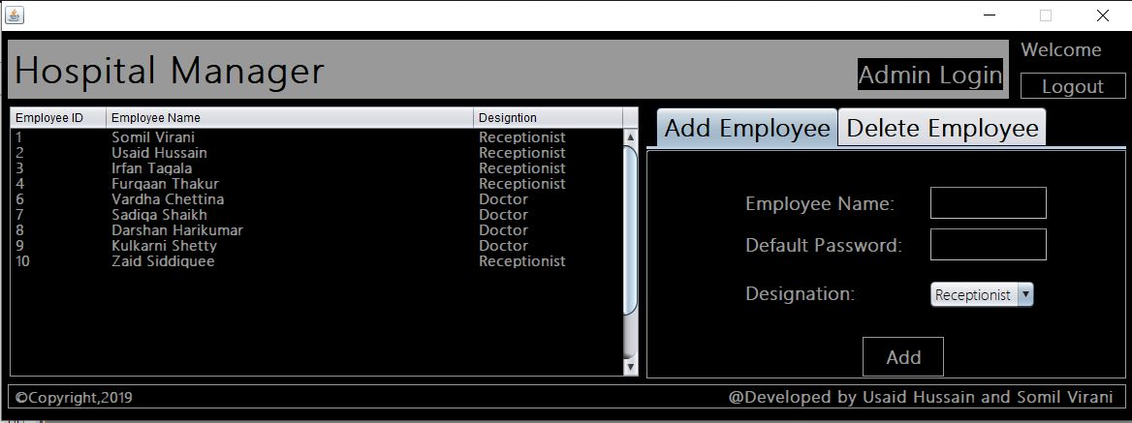

Fig: Admin login(add and delete employees)

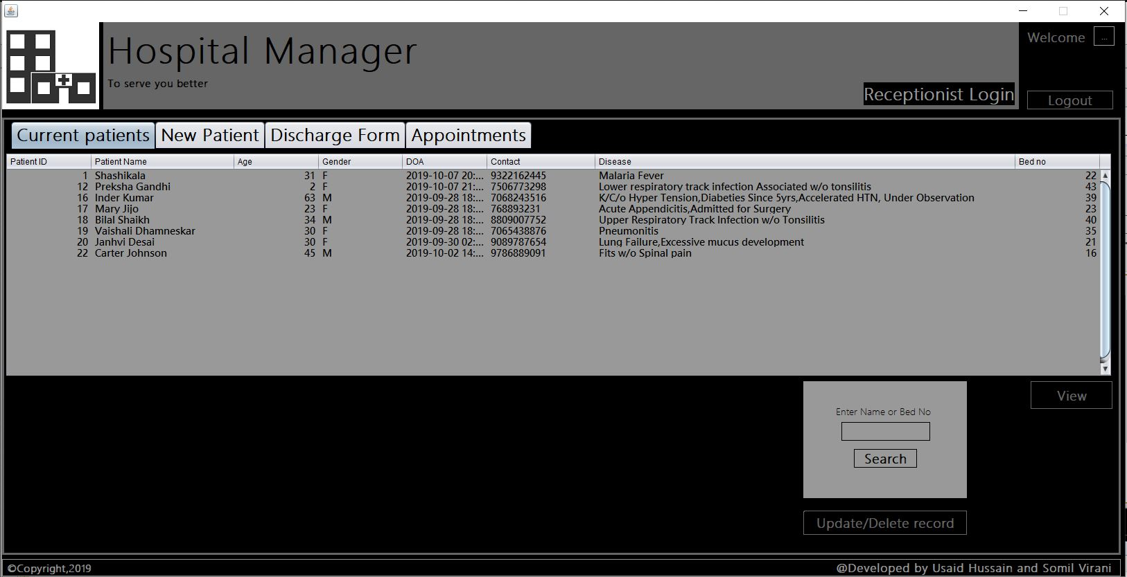

Fig: Current patients admitted with bed number

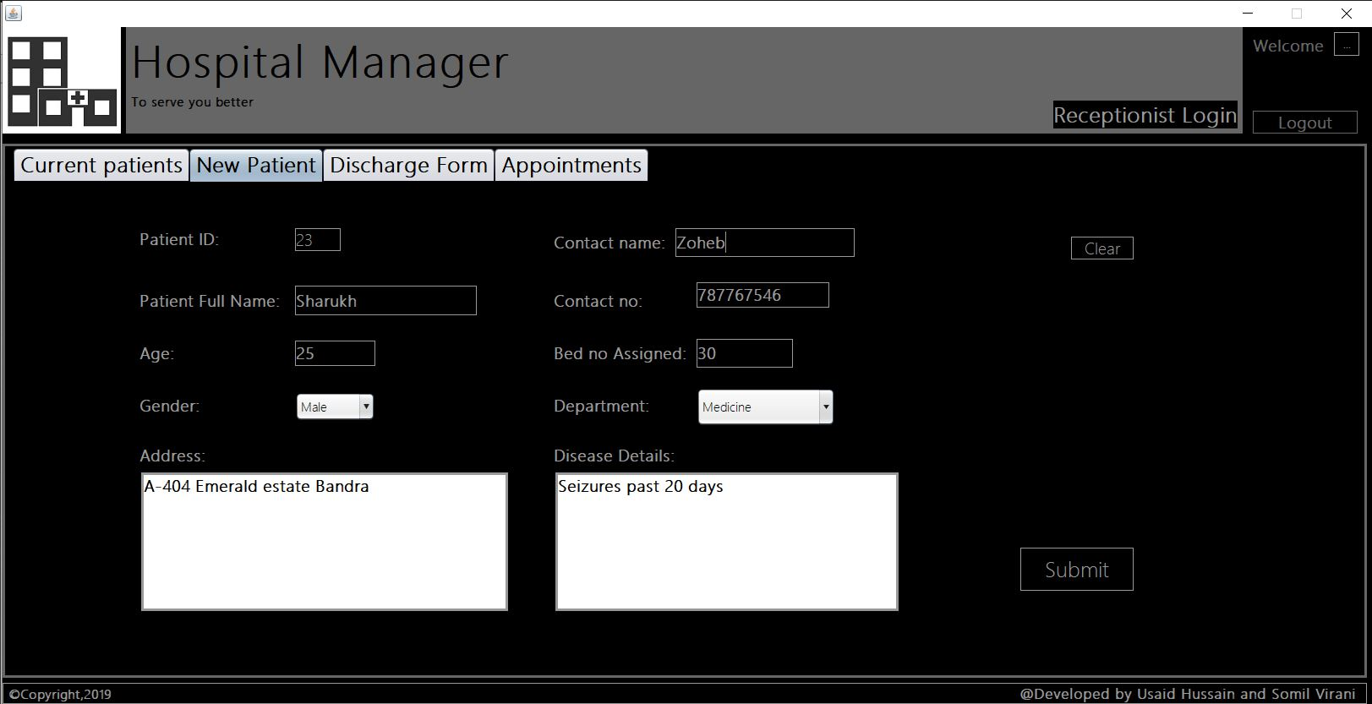

Fig: New patient form

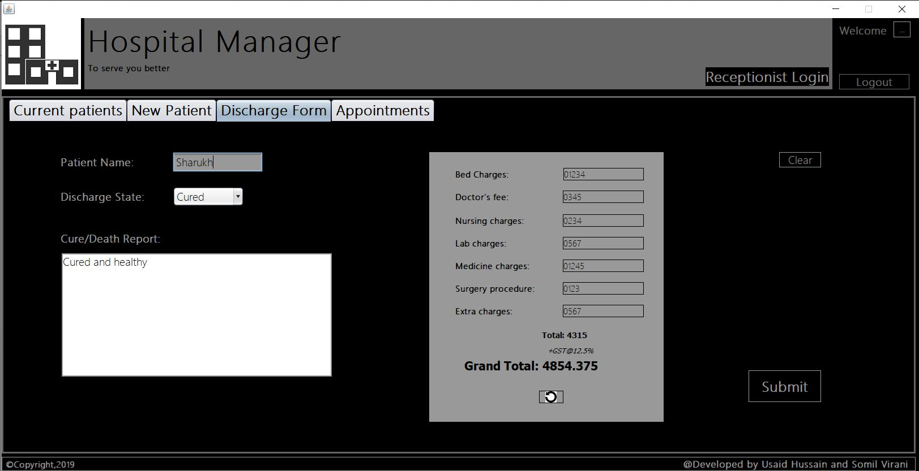

Fig: Discharge form

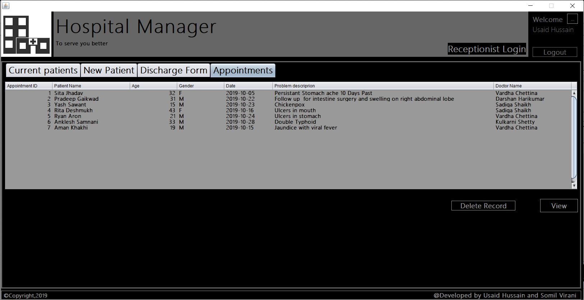

Fig: View all appointments

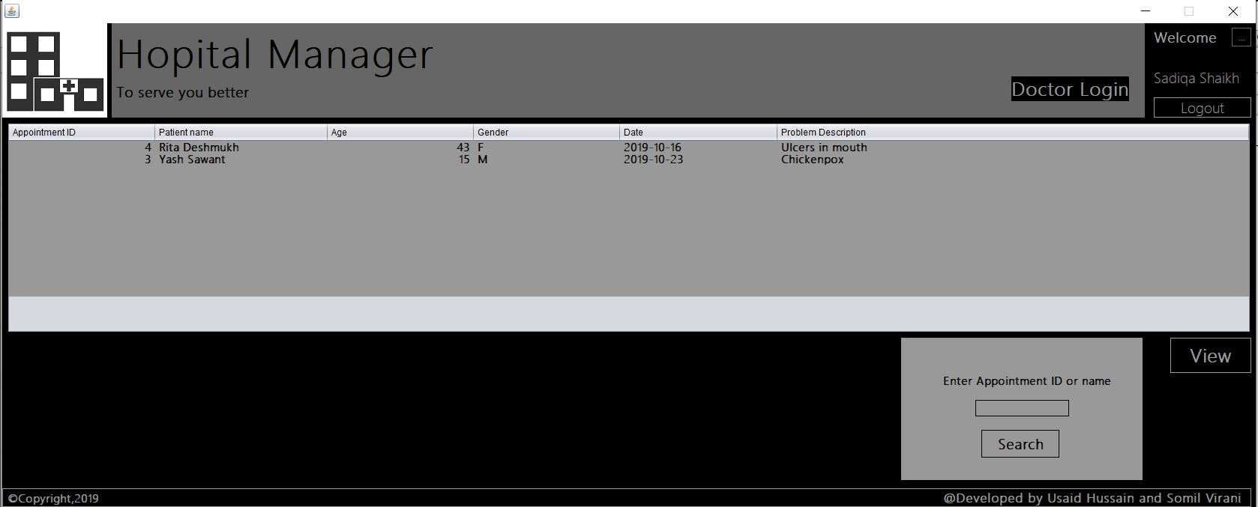

Fig: Doctors login with appointments

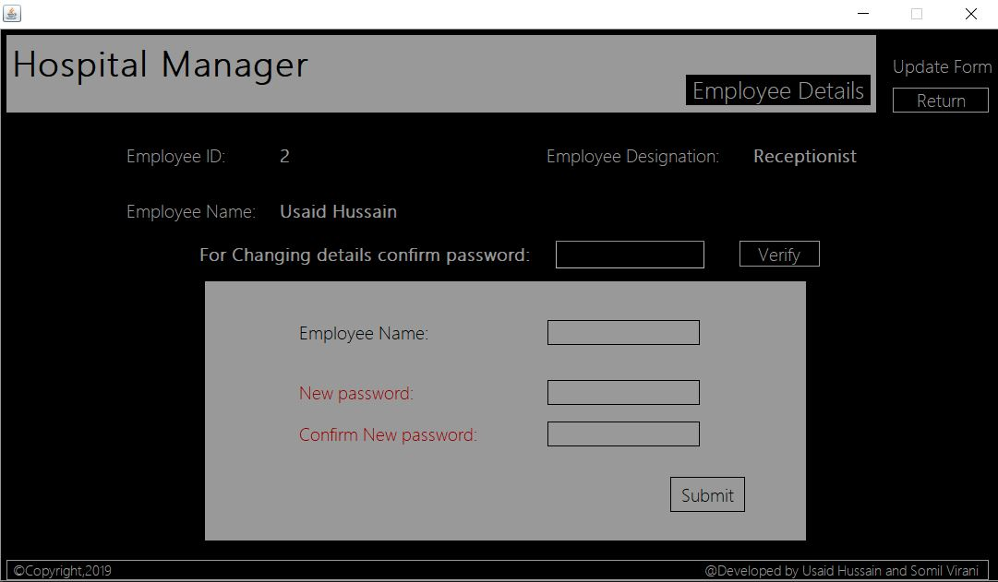

Fig: Form for self details viewing and updating